**Format for uploading details in GitHub and Slack in word file format**

**Student Name: Shreetal kalabandi**

**Class and Sec: VI B**

**USN: 4AL17CS091**

|  |  |  |  |  |
| --- | --- | --- | --- | --- |
| **Online Test Details** | | | | |
| **Subject** | **Operating System** | | | |
| **Semester** | **VI - B** | | **Duration** | **30 Minutes** |
| **64%** | | **19/30** | | |

**Encl: snapshot of the test result**

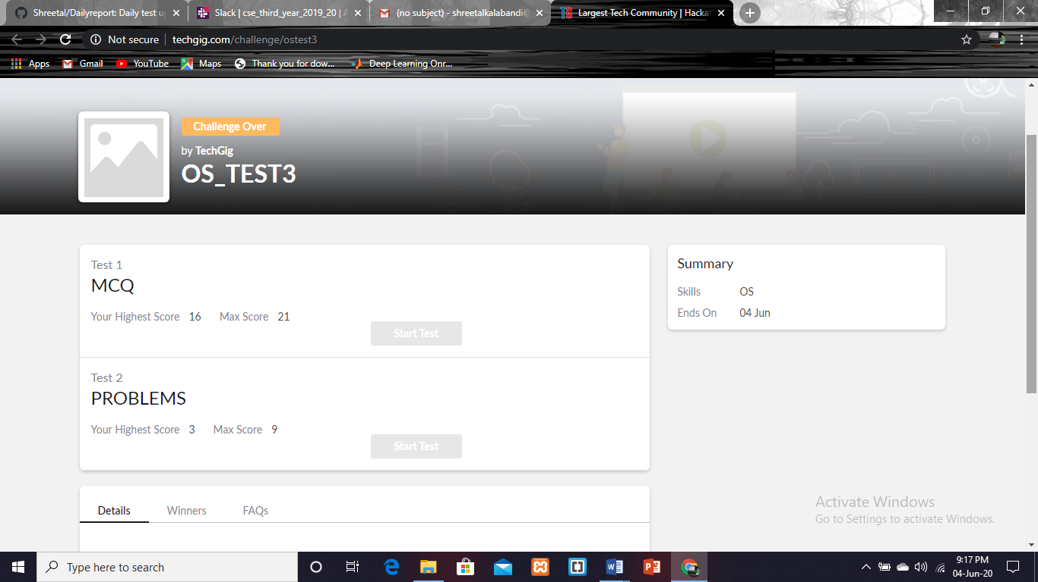

|  |  |  |  |
| --- | --- | --- | --- |
| **Certification Course Details** | | | |
| **Course** | **Blockchain essentials** | | |
| **Certificate Provider** | **Cognitioclass** | **Duration** | **6 hrs** |

**Encl: snapshots of the daily class activities (at least two snap shots)**

**Progress on 04-06-2020**

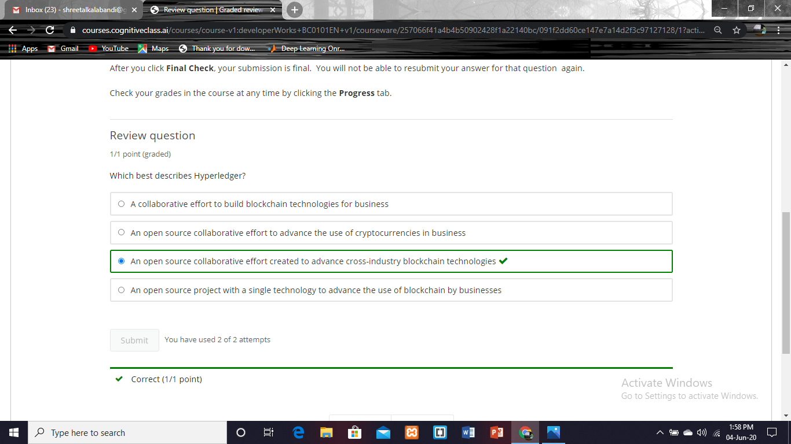

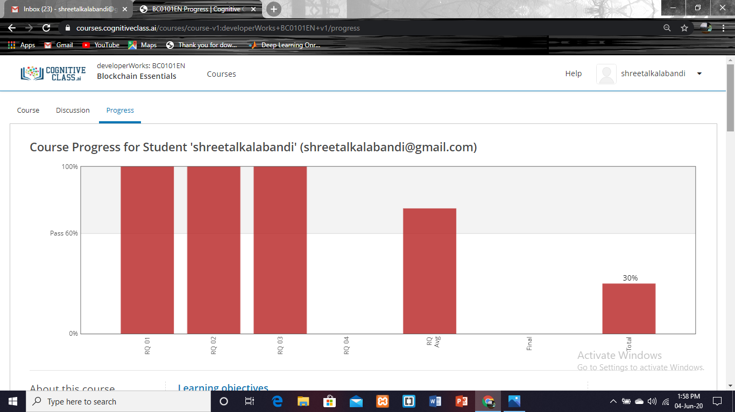

|  |  |
| --- | --- |
| **Coding Challenges** | |
| **Problem Statement:**  **Pro1(python)**  **Take two strings, return a string of the form short+long+short, with the shorter string on the outsides and the longer string on the inside. The strings will not be the same length, but they may be empty (length 0).**  **Pro2(java)**  **Java program to implement Queue Using Array And Class.**  **Pro3(python)**  **Python Program to Accept a Hyphen Separated Sequence of Words as Input and Print the Words in a Hyphen-Separated Sequence after Sorting them Alphabetically.** | |
| **Status: Completed** | |
| **Uploaded the report both in GitHub & Slack** | **Yes** |

**Encl: snapshots of your response to challenge.**

**prog1**

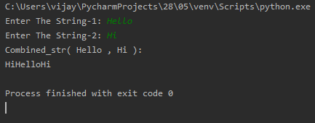

**prog2**

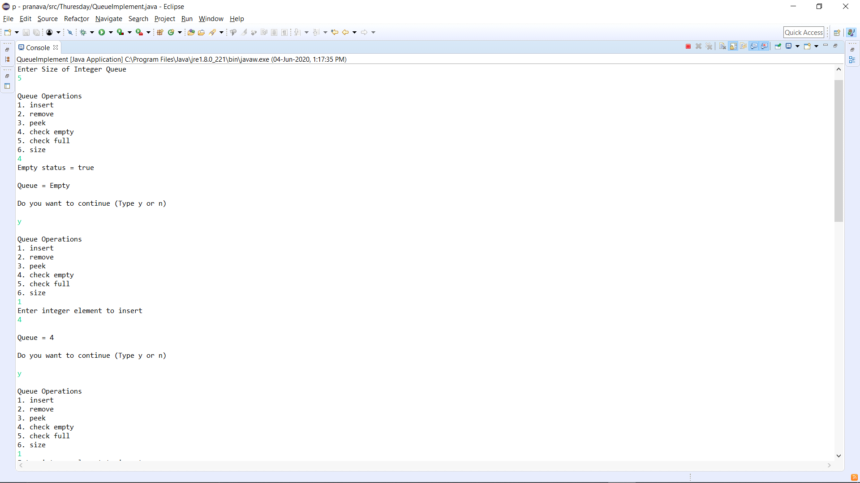

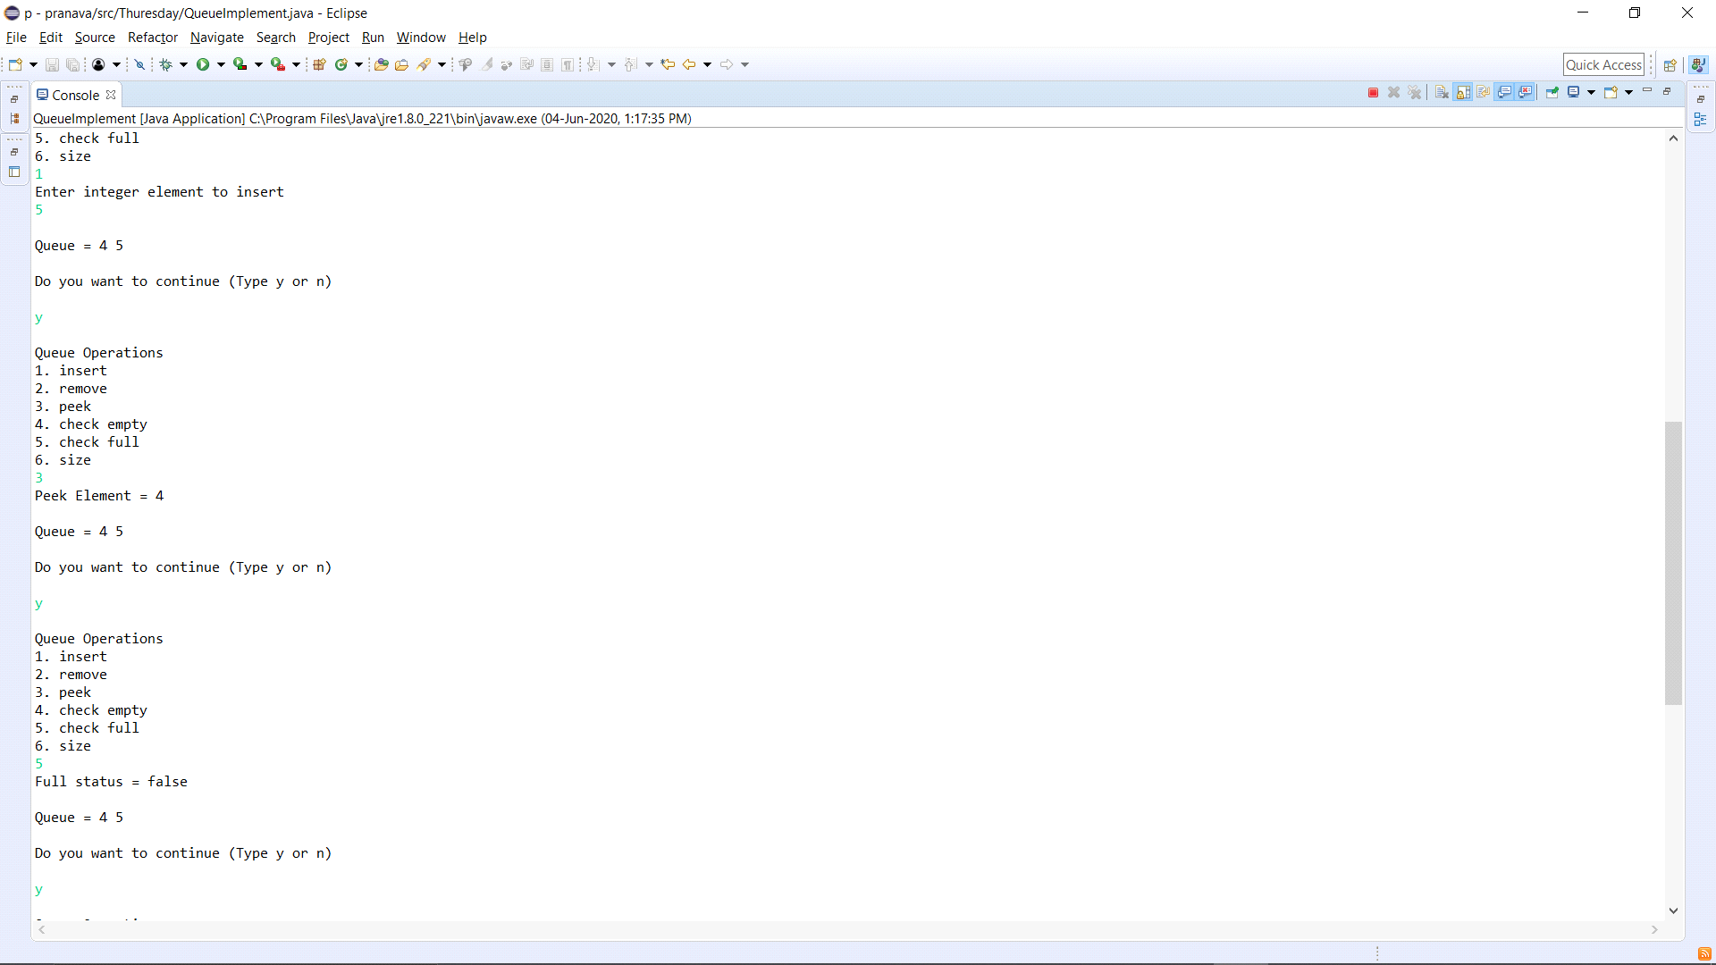

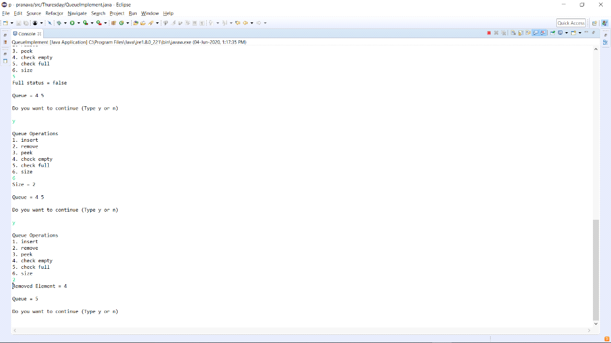

**prog3**

